User Guide
The cinema booking website
ICT Engineering
Martin Krisko 240314
Miroslav Fratric 240160

1.Starting the webpage

1.Enter the URL into your browser

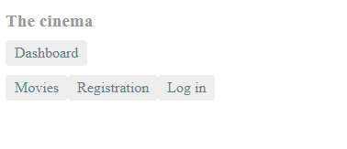
2. Visitor

As a visitor of the web page you will have 3 options to select from.

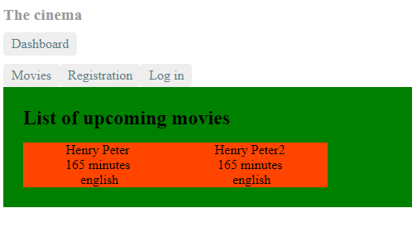
2.1 Movies
1.If you want to see the list of movies being played in upcoming days, select Movies from the menu.

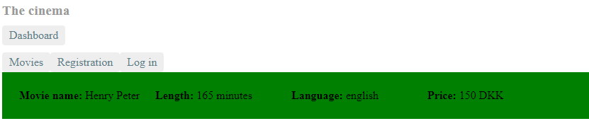
2.1.1 Movie detail
1.To see more details about a movie, select the movie from the list.

2.2 Registration
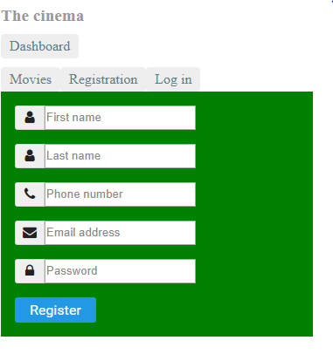
1.If you want to reserve a ticket for a movie and you are not registered user, select Registration from the menu.
2. The registration form will appear. You need to enter your first name, last name, phone number, email address and password.
3. After you fill in all the fields correctly and clicking on the Register button you will gain access to the movie reservation feature.
4. You will be automatically logged in after registration.

2.3 Log in
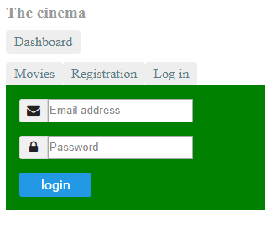
1. If you already have an account for the web page select log in from the menu.
2. Enter your email and password.
3. To complete the process click, on the Login button.

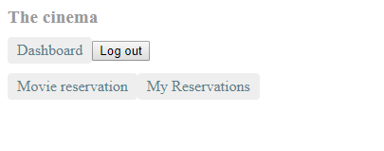
3. User
1. When you are logged in you will have a possibility to select from Movie reservation, My reservations and Log out.

3.1. Movie reservation
1. If you wish to reserve a movie select the Movie reservation from menu.
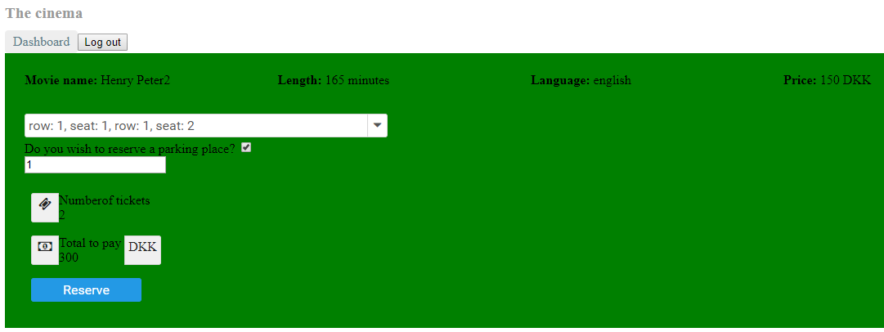
2. Select a movie you desire to make a reservation for.

3. You will see more details about the movie and you will be able to select your desired seats in the first field.
4. If you wish to reserve a parking place for your visit click on the check box on the right side of Do you wish to reserve a parking place and enter the number of parking seats you wish to reserve. The number of parking places you can reserve is limited by the number of tickets you reserve.
5. After you fill in the fields you will be able to see Number of tickets that you have ordered and Total to pay which indicates the price for the tickets.
6. Click Reserve to finish the reservation.

3.2. My reservations
1. If you wish to see the preview of your reservations select My reservations from the menu.
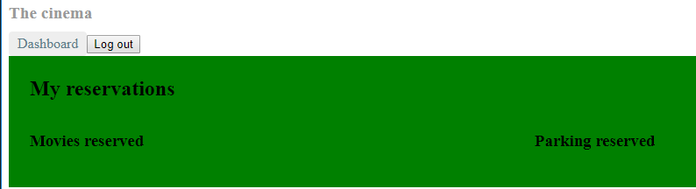
2. You will see the reservations for movies and parking places made from your account.

3.3. Log out
1. To log out from the application click on the Log out button in the menu.

4. Admin

4.1. Log in
1. Select Log in from the menu
2. Enter your email and password.
3. To complete the process click, on the Login button.

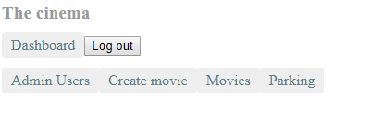
4.2. Admin Preview
1. As an admin you have access to Admin users, Create Movies, Movies and Parking from your dashboard.

4.3. Admin users
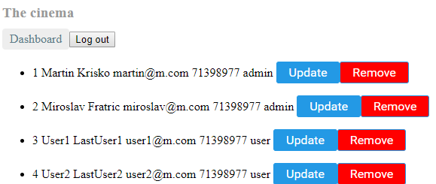
1. To see the list of registered users select Admin users from the menu.

4.3.1. Update user
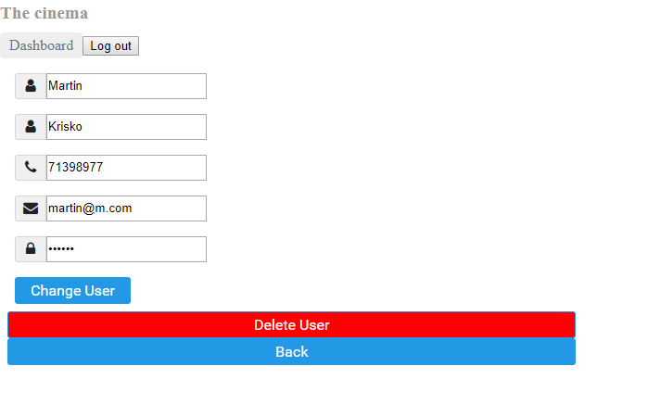
1. If you wish to change details about users click on the Update button next to user you wish to change.
2. Change the value in the field you desire to change.
3. Click on Change User to save the changes.

4.3.2. Remove user
1. To remove a user from the database of users click on the Remove button next to the user.

4.4. Create movie
1. To create a movie select Create movie from the menu.2. Fill in the fields required for the movie to be saved.
3. Click Save show to finish the process.

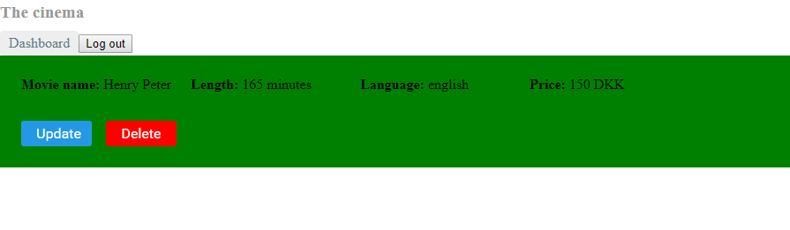
4.5. Movies
1. To update movies select Movies from the menu and then the movie you wish to update.
3. Click Delete to remove the movie from the list of shows.

4.6. Parking
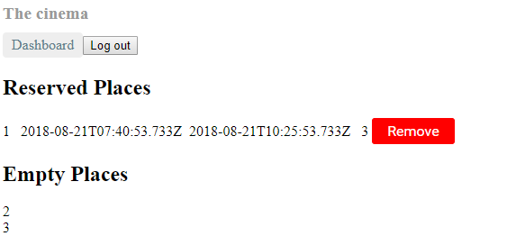
1. To see the preview of the parking lot select Parking from the menu
2. You will see the start and end time of the reservations of the parking places.
3. Click Remove to cancel a reservation of a parking place.

